Chapter 7 TESTING

* In table 7.2, Checking is done for null/NA value after dropping.

**Table 7.2 Unit test to check for null/NA value**

|  |  |
| --- | --- |
| Sl No. of test case: | 2 |
|  |  |
| Name of test: | Check test |
|  |  |
| Item / Feature being tested: | Dataframe object |
|  |  |
| Sample Input: | Drop command to drop null/NA values |
|  |  |
| Expected output: | No null/NA value in dataframe |
|  |  |
| Expected output: | No null/NA value in dataframe |
|  |  |
| Remarks | Test Succeeded |
|  |  |

**7.2 Integration Testing**

Integration testing is done to test the modules/components when integrated to verify that they work as expected i.e. to test the modules which are working fine individually does not have issues when integrated. It is used to check the train and test split function as shown in table 7.3 and the output seen in figure 7.2 as shown below.

**Table 7.3 Integration test to check for train-test-split**

|  |  |
| --- | --- |
| Sl No. of test case: | 1 |
|  |  |
| Name of test: | Check test |
|  |  |
| Item / Feature being tested: | Train-test-split function |
|  |  |
| Sample Input: | Input features and ratio and check for the correct splitting |
|  | of the dataframe |
|  |  |
| Expected output: | Split according to the given ratio |
|  |  |
| Expected output: | Splitted according to the given ratio |
|  |  |
| Remarks | Test Succeeded |
|  |  |

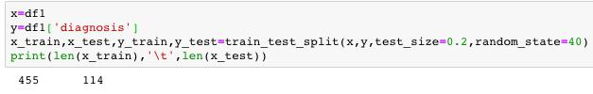

**Figure 7.2 Splitting the dataset into the ratio 4:1**

|  |  |  |
| --- | --- | --- |
| Department of CSE, RNSIT | 2018-2019 | 35 |

Chapter 7 TESTING

**7.3 System Testing**

System Testing (ST) is a black box testing technique performed to evaluate the complete system the system's compliance against specified requirements. The software or hardware is testing conducted on a complete, integrated system to evaluate the system’s compliance with its specified requirements. System testing takes, as its input, all of the ‘integrated’ software components that have successfully passed integration testing and also the software system itself integrated with any applicable hardware system(s).

* In table 7.4, one is checking accuracy using logistic regression algorithm and the output is shown in figure 7.3 as shown below.

**Table 7.4 System test to check the accuracy using Logistic Regression**

|  |  |
| --- | --- |
| Sl No. of test case: | 1 |
|  |  |
| Name of test: | Check test |
|  |  |
| Item / Feature being tested: | Learning algorithm’s efficiency |
|  |  |
| Sample Input: | Training features and output feature |
|  |  |
| Expected output: | Some accuracy of the training model |
|  |  |
| Expected output: | Training accuracy: 96.04% |
|  | Testing accuracy: 92.10% |
|  |  |
| Remarks | Test Succeeded |
|  |  |

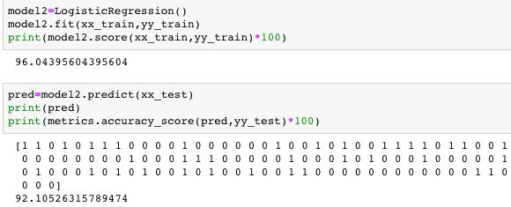

**Figure 7.3 Accuracy using Logistic Regression**

|  |  |  |
| --- | --- | --- |
| Department of CSE, RNSIT | 2018-2019 | 36 |

Chapter 7 TESTING

* In table 7.5, one is checking accuracy using Random Forest Algorithm and the output is shown in figure 7.4 as shown below.

**Table 7.5 System test to check the accuracy using Random Forest**

|  |  |
| --- | --- |
| Sl No. of test case: | 2 |
|  |  |
| Name of test: | Check test |
|  |  |
| Item / Feature being tested: | Learning algorithm’s efficiency |
|  |  |
| Sample Input: | Training feature and output feature |
|  |  |
| Expected output: | Some efficiency of the learning algorithm |
|  |  |
| Expected output: | Improved efficiency |
|  | Training efficiency: 99.78% |
|  | Testing efficiency: 94.73% |
|  |  |
| Remarks | Test Succeeded |
|  |  |

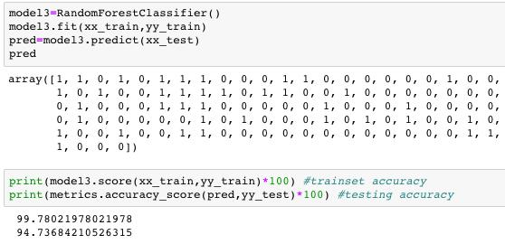

**Figure 7.4 Accuracy using Random Forest Algorithm**

|  |  |  |
| --- | --- | --- |
| Department of CSE, RNSIT | 2018-2019 | 37 |